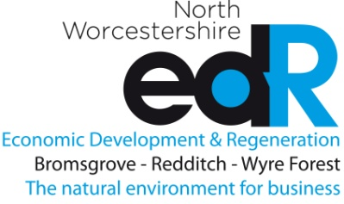 SUMMARY OF CURRENT BUSINESS SUPPORT PROGRAMMES 27/04/2022
START | GROW | RECOVER | INNOVATE
Enterprise for Success  Enterprising Worcestershire  Peer to Peer Network from Greater Birmingham & Solihull LEP Growth Hub | Elevate Programme Worcestershire  Elevate Technology  Manufacturing Growth Programme  NWedR Booster Grant | Elevate Programme Worcestershire | Low Carbon Growth Support Project  BetaDen North – Cleantech Commercial Programme  WINN

RELOCATE | RECRUIT | UP-SKILL | SPECIALIST SUPPORT PROGRAMMES
 | The Development Manager | Skills Support for the Workforce  The Development Manager | Zero Carbon Ready Worcestershire | Worcestershire County Council.  Business Energy Efficiency Programme  Low Carbon Growth Support Project

